**INFORMATION SEARCH AND ANALYSIS SKILL (ISAS)**



**“Technology Architecture on e-Commerce Website Tokopedia”**

Written by:

**Fikhri Maheswara Taswandi**

**Alif Nur Rachman**

Faculty:

**Reza Maulana**

Class:

**3WD1**

**CEP CCIT – Fakultas Teknik Universitas Indonesia Gedung Engineering Center Lt.1, Kampus Baru UI Depok 1**

**PREFACE**

First of all, the authors would like to thank to God the Almighty who has given health and opportunity to complete this paper. Besides that, the authors would like to say thank you to our faculty Mr. Reza Maulana that really help and guide the authors.

This paper is submitted to fulfill the 2nd ISAS (Information Search Analysis System) in 3rd Semester entitled “**Technology Architecture on e-Commerce Website Tokopedia**”. This paper will discuss about foundational theory, how technology architecture works, advantages and disadvantage, and its implication on an e-commerce website called “Tokopedia”

The authors realized that this paper still imperfect in arrangement and the content, then the authors hope to receive comments and suggestions from the readers that can help the authors in perfecting the next paper. Hopefully, this paper can be used as a reference to learn about.

|  |  |
| --- | --- |
|  | Depok, 11 November 2024    Author |

# TABLE OF CONTENTS

TABLE OF CONTENTS ii

CHAPTER I INTRODUCTION 3

1.1 Background 3

1.2 Writing Objectives 3

1.3 Problem Domain 3

1.4 Writing Methodology 4

CHAPTER II BASIC THEORY 5

2.1 The Theory of Technology Architecture 5

2.2 Tools for Technology Architecture 8

CHAPTER III PROBLEM ANALYSIS 9

CHAPTER IV CONCLUSION AND SUGGESTION 10

BIBLIOGRAPHY 11

# CHAPTER I INTRODUCTION

## Background

Technology architecture is an architecture that combines application components with software and hardware components to form an organization of technological infrastructure. Technology architecture provides a roadmap within each technology platform to ensure the right tools and development options are utilized. The maps of technology architecture include physical infrastructure with information, processes, and organization structural. It also outlines the logical component, such as software, middleware, and data, that interacts within the infrastructure. These maps are important for understanding the overall system, identifying potential bottlenecks, and planning for future growth and changes.

In this ISAS, we will be learning about technology architecture, that includes its definition, key component, principles, and best practices. We will also explore real-world examples of technology architecture in e-commerce industry. By the end of this ISAS, you will have more knowledge about technology architecture.

## Writing Objectives

This ISAS Research paper is made for:

1. Learn in-depth about Technology Architecture

2. Give better understanding about Technology Architecture

3. Breakdown the technology architectural used in e-commerce site

## 1.3 Problem Domain

In this section, we want to discuss problems about:

1. Implementation of Technology Architecture

2. The scalability, performance, and security risk of Technology Architecture

3. Analyse Tokopedia Technology Architecture

## 1.4 Writing Methodology

The author has used a number of methods for this ISAS. Library research was the primary technique used to write this ISAS. Data collection was done by browsing reference materials studied from websites related to the topic of this ISAS. Analytical discussion was used as an additional writing strategy for this ISAS. After collecting data from reference sources, we discussed and organised the data into a content structure to complete this ISAS.

**1.5 Writing Framework**

Analyst of this ISAS is written with this systematics:

* **CHAPTER I: INTRODUCTION**

In this section, we will describe the background, problem domain, writing objectives, and writing methodology.

* **CHAPTER II: BASIC THEORY**

In this section contains: Explanation about Technology Architecture

* **CHAPTER III: PROBLEM ANALYSIS**

In this section, we will be discussing about implementation and problems of Technology Architecture

* **CHAPTER IV: CONCLUSION AND SUGGESTION**

This chapter contains the conclusions of the results of writing and suggestion.

* **BIBLIOGRAPHY**

In this section, it contains the references that we use to make this ISAS.

# 

# CHAPTER II BASIC THEORY

## 2.1 The Theory of Technology Architecture

Technology Architecture is a form of architecture that is used as a framework and guidelines for an organization’s business objectives. It encompasses the hardware, software, networks, and data that form the foundation of a system or application. Technology Architecture ensures the technology solution aligns with the organization’s meet and goals.

A well-designed technology architecture promotes scalability, flexibility, and maintainability. It enables efficient integration of new technology and facilitates upgrades and modification made along the way. By providing a clear roadmap for development and deployment, it mitigates risks from happening.

There are different types of technology architecture that exist, with each focusing on different aspects of a system’s design and implementation. The commonly used technology architectures are the following:

* **Enterprise Architecture (EA)**

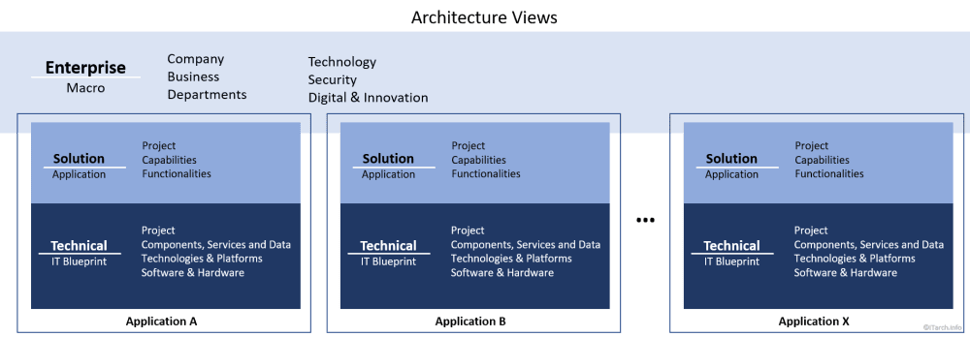Enterprise Architecture is an architecture that defines the complete blueprint of the whole company. It includes all applications and IT systems that are used within the company and by different companies’ departments. The objective of an enterprise architecture is to focus on making IT work for the whole company and fit the companies’ goal.

Figure 1.2  
Enterprise Architecture

* **Solution Architecture**

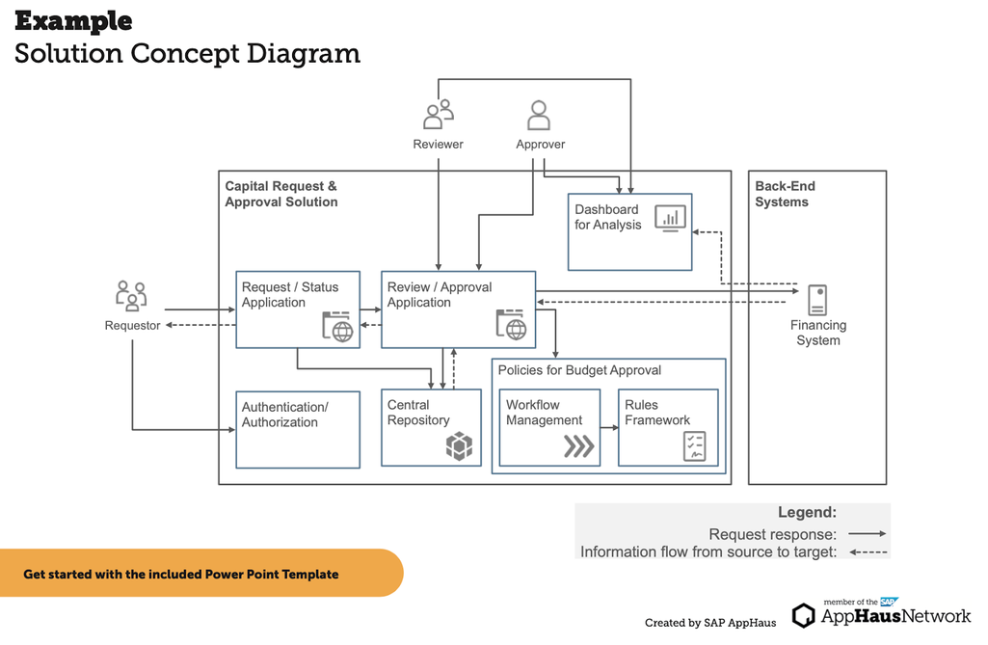Solution Architecture is an architecture that is built for a specific system that needs to perform a certain task, it usually involves in designing, implementing, and managing technology solution to address specific problems and opportunities. A solution architecture typically applies to a single project or project release and facilitates the translation of requirements into a solution vision.

Figure 1.2  
Solution Architecture

* **Application Architecture**

Application Architecture is an architecture that deals with the design,development, and deployment of software application. It focuses on the application’s functional and non-functional requirement, as well as its interaction with other systems. Application architects define the application’s architecture, including its components, modules, and interfaces.

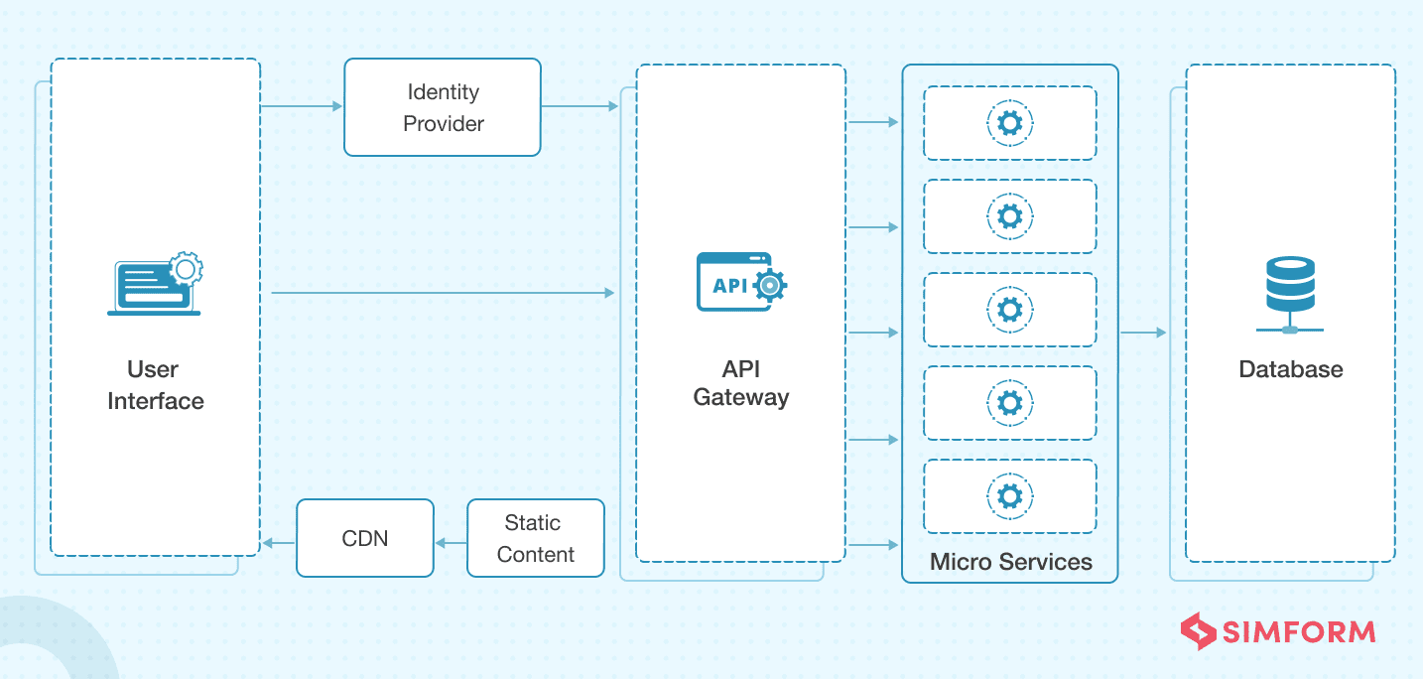

Figure 1.3  
Application Architecture

* **E-Commerce Architecture**

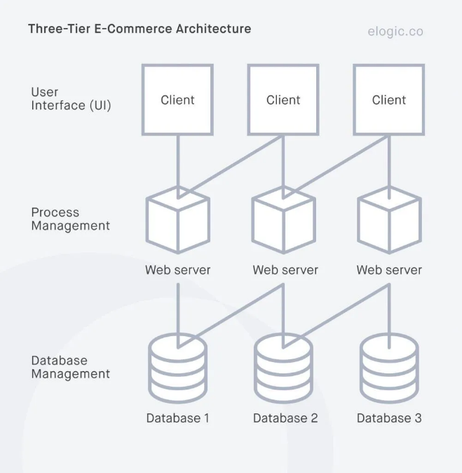E-Commerce Architecture is an architecture that is used for an online store and focuses on its technical component, their interaction, and how they collectively support the business. In order to support the massive growth in online transaction and demands for scalability, E-commerce architecture must implement a multi-tier architecture.

Figure 1.4  
E-Commerce Architecture

* **Data Architecture**

Data Architecture focuses on the design and management of an organization’s data assets. It involves defining data models, data flows, and data storage strategies. Data architects ensure that data is accessible, accurate, and secure.

* **Security Architecture**

Security Architecture is an architecture that focuses on protecting an organization’s information assets from threats. It involves designing security policies, standards, and controls to mitigate risks.

## 2.2 Tools for Technology Architecture

Technology architects employ a variety of tools to design, analyse, and communicate complex systems. Well-thought-out diagrams give teams an enhanced understanding of the design and plan for future development whilst identifying potential issues. Here are a few examples of tools used by technology architects.

* **Modelling Tools**

Modelling tools are used to create a wide range of diagrams, including UML diagrams, BPMN models, and other architectural artifacts. It is useful when it comes to visualizing complex systems. Commonly used modelling tools software are:

**-** Sparx Systems Enterprise Architect

**-** ArchiMate Tooling

**-** Cameo System Modeler

* **Collaboration Tools**

A collaborative platform enables teams to create and share documents, diagrams, and knowledge bases. It’s ideas for capturing and sharing architectural decisions and design patterns. Commonly used collaboration tools are:

- Microsoft Teams

- Jira

- Confluence

* **Version Control System**

A distributed system is a software that allows architects to track changes to their architectural design and code. It enables collaboration, experimentation, and rollback to previous versions. Commonly used version control systems are:

- Git

- SVN (Subversion)

* **Cloud Platforms**

A cloud platform is a combination of hardware, software, and operating system that provides cloud computing services. It is useful for building and deploying applications on a large scale. Commonly used cloud platforms are:

- Amazon Web Service

- Microsoft Azure

- Google Cloud Platform

# CHAPTER III PROBLEM ANALYSIS

# CHAPTER IV CONCLUSION AND SUGGESTION

# BIBLIOGRAPHY

<https://www.sciencedirect.com/topics/computer-science/technology-architecture>

<https://www.leanix.net/en/wiki/it-architecture/technical-architecture>

<https://www.simform.com/blog/web-application-architecture/>

<https://www.geeksforgeeks.org/e-commerce-architecture-system-design-for-e-commerce-website/>

<https://elogic.co/blog/ecommerce-architecture/>

<https://www.itarch.info/2020/05/what-is-it-architecture-and-different.html>

<https://www.altexsoft.com/blog/solution-architecture/>